ICU Patient Monitoring System

Kuye Doluwamu Taiwo
Electrical Engineering
University of applied Sciencs Hamm Lippsdadt
Lippsdadt,Germany
Doluwamu-taiwo.kuye@stud.hshl.de

Abstract— Doctors and other health-care professionals, especially those working in the critical care unit, must be aware of their patients' vital signs. Patient monitoring is the premise for this paper. We designed and built a patient monitoring system that is both dependable and effective. It sends the doctor real-time patient parameters, allowing them to monitor the patient's health. Making patient data more accessible will improve patient–doctor communication.

Keywords—microcontroller, sensors, patient, doctor

Introduction
One of the most essential things nowadays is one's health. Patients in intensive care units require regular attention and observation, and their current status must be properly documented at all times so that doctors may react quickly and effectively. Doctors cannot constantly be present in the intensive care unit, nor can they visit and monitor every patient at the same time; as a result, while attending to one patient, another may experience an emergency. Patients may experience difficulties as a result of this, and clinicians could feel helpless in the situation. The patient monitoring device provides a solution to these issues by continuously displaying vitals and alerting the doctor if any anomalous readings are detected.
Continuous monitoring of patient parameters such as heart rate and rhythm, respiration rate, blood pressure, blood oxygen saturation, and a variety of other parameters has become a standard part of critical care.
Precise and rapid decision-making is crucial for optimal patient care; electronic monitors are commonly used to collect and display physiological data. In critically ill or otherwise vulnerable people, a patient monitor is often conceived of as something that watches for and warns against serious or life-threatening events. Patient monitoring is described as the frequent or continuous observation of a patient's physiological function with the purpose of guiding management decisions such as when to administer therapeutic measures and how effectively they perform. A patient monitor alerts caregivers to potentially life-threatening conditions.
Patient monitoring, which is largely employed in the intensive care unit and operating room, refers to the continuous observation of recurrent occurrences of physiological function in order to guide therapy or monitor the effectiveness of interventions.
The ECG, blood pressure, arterial oxygen saturation, and cardiac output are all signals that are commonly processed.
Sensors are incorporated into the proposed system to monitor vital indications of the human body such as heart rate, temperature, and blood pressure. The analog human vital bodily signals are transferred to an ADC and then to a microcontroller. The LCD attached to the microcontroller displays the output of various sensors while simultaneously storing the output in the microcontroller's memory. The heart rate is measured using a technique known as photoplethysmography (PPG). A thermos sensor, the LM35, is used to measure the body temperature. It measures the temperature directly in Fahrenheit and does not require additional calibration. A pressure sensor measures blood pressure, and the signals are conditioned with an instrumentation amplifier before being converted to data by an ADC.As a result, we can use a pic microcontroller to provide many inputs in the form of body parameters, and outputs based on the inputs can display the required findings on an LCD.

CONCEPT

Main elements of the system
People
• Doctors/Nurse (monitoring output of the system)
• Patient (supplying input to the system)

Device
- temperature sensor
- heartbeat sensor
- blood pressure sensor
- blood oxygen sensor
- Spo2 sensor
- Touchscreen
- ECG sensor
- Speaker
- Touchscreen interface

Requirement
- System must operate in real time
- Patient demographics must be displayed
- System must be reliable
- Systems must be fully functional
- System must fulfil all safety requirements
- System must have alarms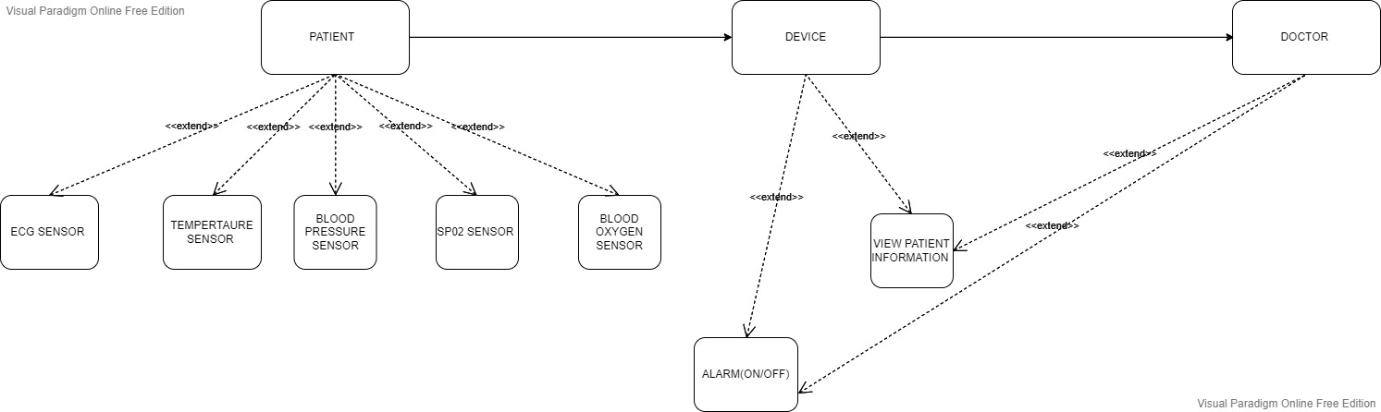

Fig 1: system diagram

Fig 2: Doctor using patient monitor

Concept Image
The health parameter sensors feed data to the microcontroller, which is converted by the ADC and then processed before being shown on the LCD or entering the alarm state, as shown in the block diagram below.

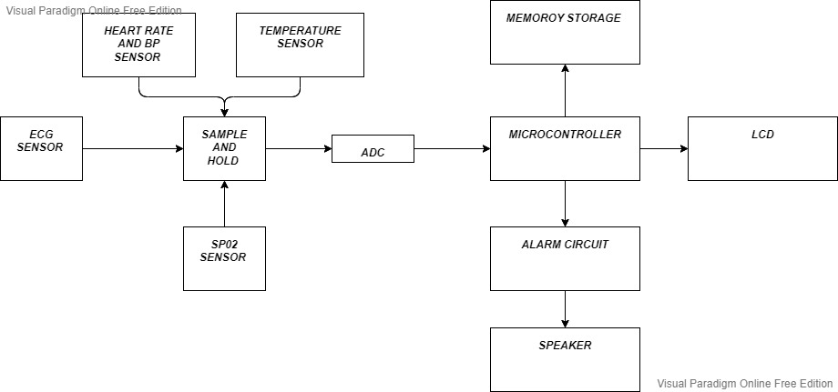Fig 3: Block diagram of the system

concept design
Various Sysml and Uml structures will be used to model a comprehensive design.

Requirement
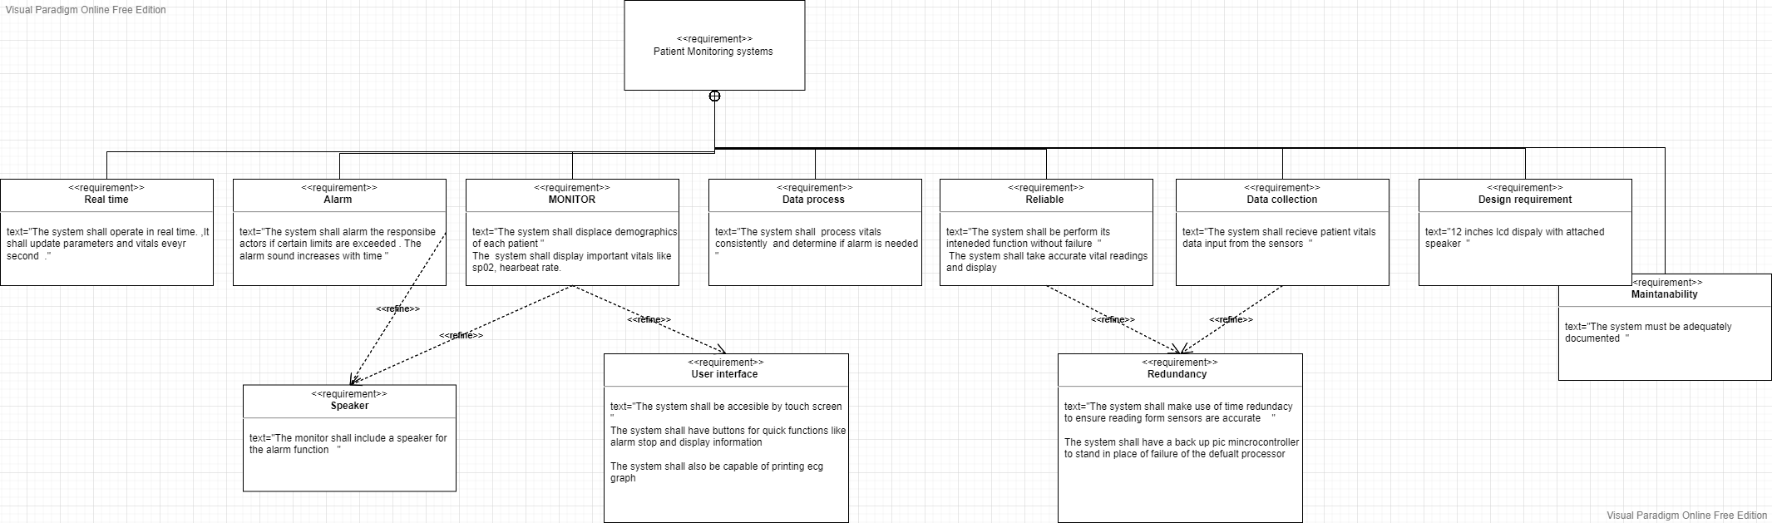
Fig 4: requirement diagram

- The system must function in real time, updating health metrics every second, and feature a monitor that displays the processed vitals and has a touch screen interface and buttons for actors to interact with. In the event of an alarm, the monitor should also feature a speaker.
- The microcontroller will process the vitals read and perform the appropriate actions, such as triggering an alarm or displaying the processed vitals.
- Health parameter sensors will be used to collect vitals data that will be processed by the system. To ensure that vitals readings are correct, the system will use time redundancy.
- A well-documented system is also required.

Concept Models

Use case
This system is used to monitor vital signs, which includes processing and displaying vital signs. Once vital signs have been processed, an alarm can be activated, and the doctor can respond properly.
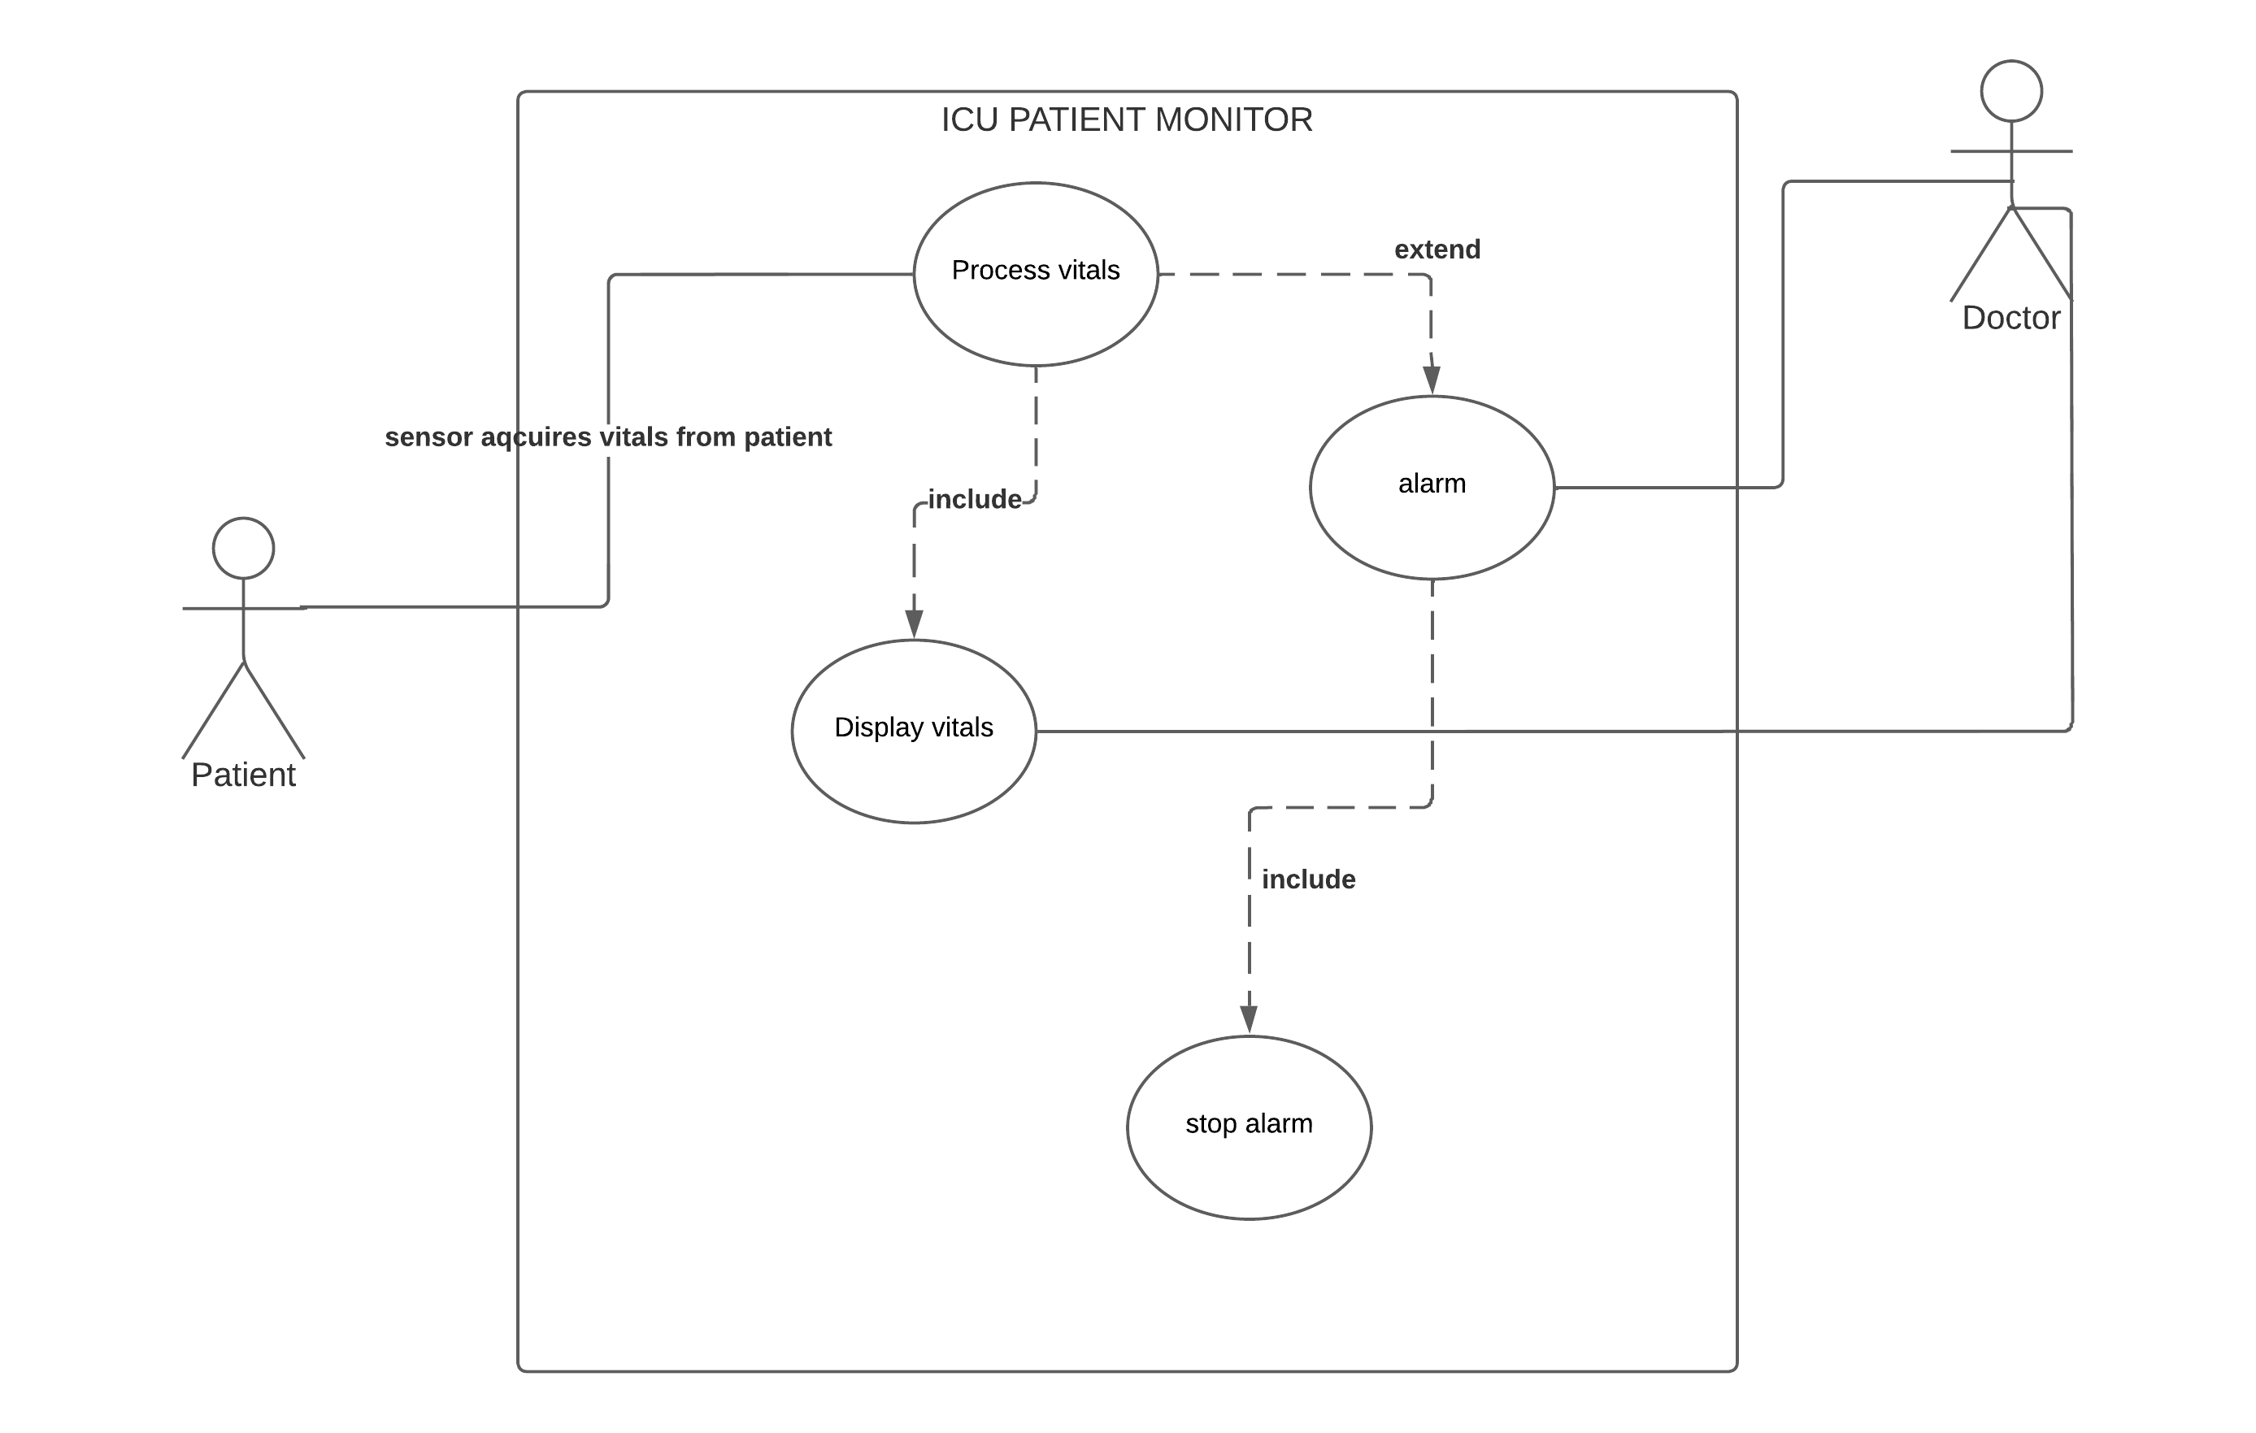
Fig 5: use case

Activity diagram
The first activity in our system is to obtain the parameters from our various health sensors such as ecg, heartrate, and blood pressure. Once this is done, the vitals are sent to the microcontroller, which processes and analyzes the data, and based on the analysis, it either goes into the display state or the alarm state. In the alarm state, there are two other states that tell the actor immediately what type of alarm it is even before it reads the vitals.
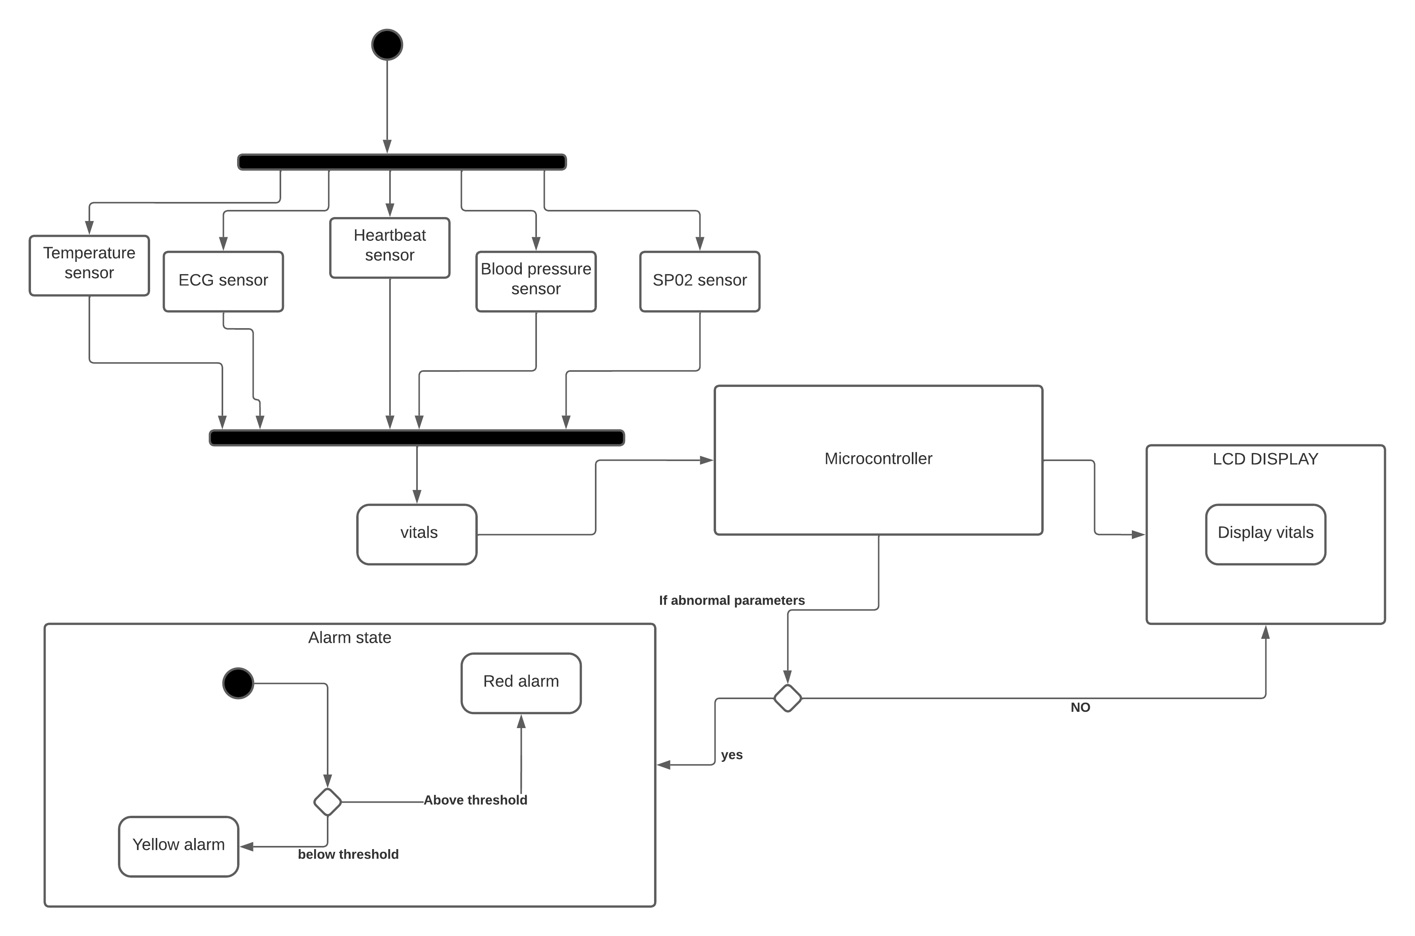
Fig 6: Activity diagram

Sequence diagram
This diagram further defines the system's behavioral structure. Sensors continuously collect patient vitals and send them to the processor. After receiving the vitals, the processor analyzes them and looks for any abnormal readings. The doctor is notified via an alarm, and the doctor can respond to the alarm by pressing the stop button.
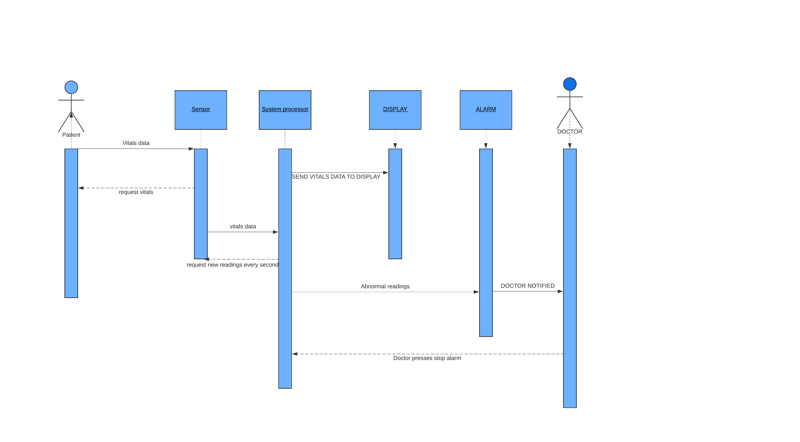
Fig 7: sequence diagram

Hardware specification

Heart rate sensor
The body parameter, heart rate, is measured using a technique known as photoplethysmography (PPG). It employs transmittance PPG, which aids in the design of a pulse sensor. It then evaluates appropriate heartbeat rates corresponding to the obtained input heart beats.
The sensor used in this project is the TCRT1000, which is a reflective optical sensor with an infrared light emitter and a phototransistor placed side by side and enclosed in a leaded package to minimize the effect of surrounding visible light.
An infrared light-emitting diode illuminates a finger. Depending on the tissue blood volume, more or less light is absorbed. As a result, the intensity of the reflected light varies with the pulsing of the blood with each heartbeat. A photoplethysmography (PPG) signal is a plot of this variation against time. The TCRT1000 is a reflective sensor that contains an infrared emitter and a phototransistor in a leaded package that blocks visible light. It is employed in optoelectronic scanning and switching devices such as index sensing, coded disk scanning, and so on (optoelectronic encoder assemblies for transmissive sensing).
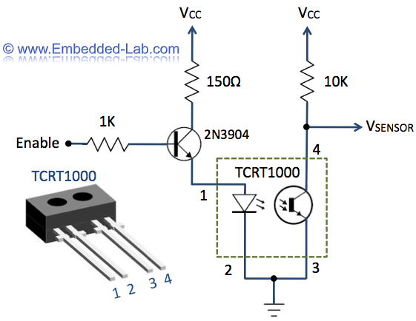
Fig 8: Tcrt1000

PIC16F877A microcontroller
The PIC16F877A is arguably the most popular 8-bit microcontroller in the PIC family of MCUs. While it’s considered by some as old and past its time, the PIC16F877A is no doubt, still one of the most popular microcontrollers in the world. It is seen as the de-facto microcontroller for beginners looking to get into embedded development with PIC and it ends up as the microcontroller of choice for them when they become experts.
It will use as our main processor.
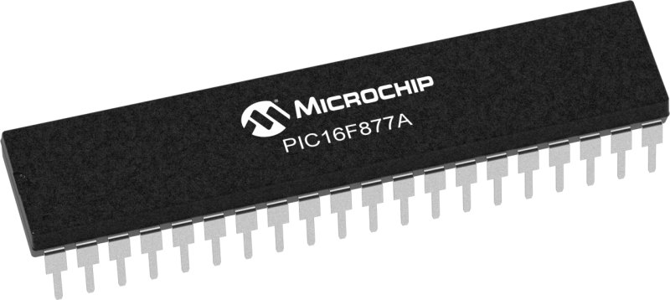
Fig 9: PIC16F877A

Blood Pressure
The pressure sensor is then given the body parameter, Blood Pressure (B.P.). The pressure sensor signal is then conditioned within an op-amp circuit or by an instrumentation amplifier before being converted to digital data by an analog-to-digital converter (ADC). The systolic and diastolic pressures, as well as the pulse rate, are then calculated in the digital domain using a method appropriate for the monitor and sensor used. The calculated systolic, diastolic, and pulse-rate values are then displayed on a liquid-crystal display (LCD). The blood pressure sensor used in the project is depicted in the figure below. [1]
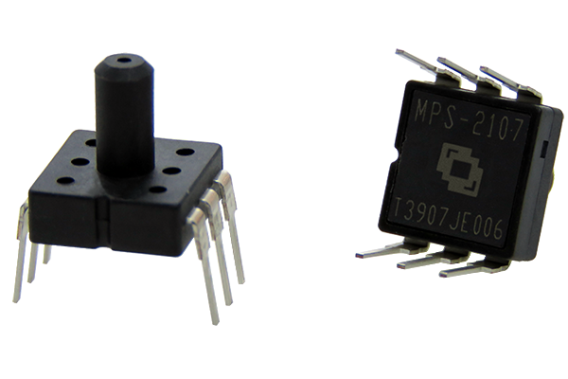

Fig 10: MPS2107

Max30102 (SP02)
MAX30100 and MAX30102 are commonly used modules for measuring heart rate. MAX30100 is a sensor that can read heart rate and blood oxygen. The communication method is through IIC. Its working principle is that the ADC value of the heart rate can be obtained through the infrared LED light, and the corresponding AD value of the heart rate can be processed through the algorithm.

Fig 11: Max30102

ECG
The electrocardiogram (ECG or EKG) is a diagnostic tool used to evaluate the electrical and muscular functions of the heart. The Electrocardiogram Sensor (ECG) has become one of the most widely used medical tests in modern times. Its use in diagnosing a wide range of cardiac pathologies, from myocardial schema and infraction to syncope and palpitations, has proven invaluable to clinicians. [1]
Fig 12: Ecg tool

Philips IntelliVue MP60 MP70 Patient Monitor Speaker
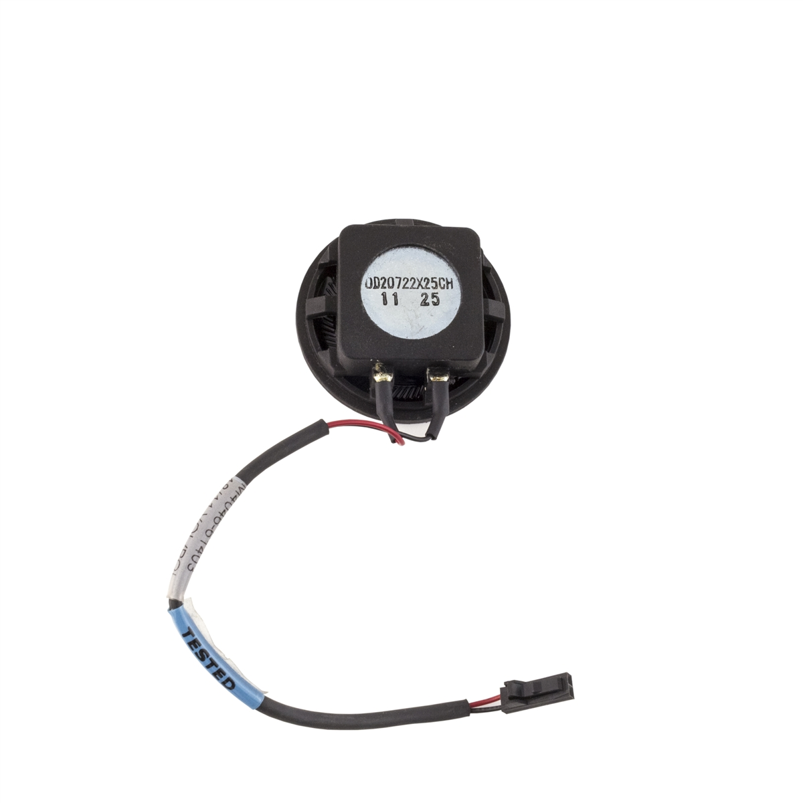
Fig 13: speaker

LM35(temperature sensor)
The LM35 series are precision integrated-circuit temperature sensors, whose output voltage is linearly proportional to the Celsius (Centigrade) temperature. The LM35 thus has an advantage over linear temperature sensors calibrated in ˚ Kelvin, as the user is not required to subtract a large constant voltage from its output to obtain convenient Centigrade scaling. The LM35 does not require any external
calibration or trimming to provide typical accuracies of ±1⁄4˚C at room temperature and ±3⁄4˚Cover a full −55 to +150˚C temperature range. Low cost is assured by trimming and calibration at the water level. The LM35’s low output impedance, linear output, and precise inherent calibration make interfacing to readout or control circuitry especially easy. It can be used with single power supplies, or with plus and minus supplies.
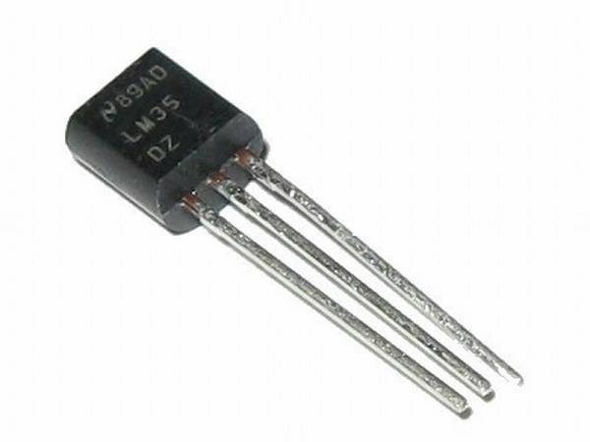
Fig 14: LM35

Monitor
A 16-inch monitor will be required to display the parameters and patient information this monitor is also where the speaker and buttons will be attached to.
Fig 15: Monitor

Hardware Specification block diagram

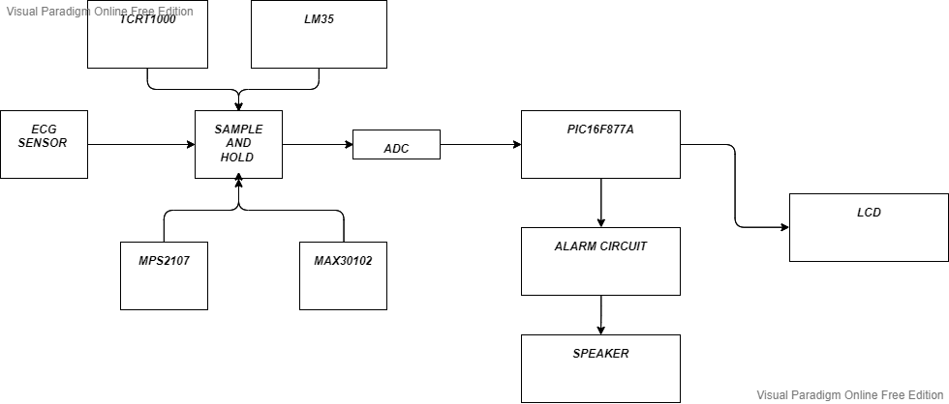

Fig 16: hardware spec block

Crictical based part of the system
Health systems are critical systems that must be carefully designed, and our system that will be used in the intensive care unit requires the implementation of save guards to immediately shut down the system in the event of false readings, as false readings can lead to doctors taking the wrong action. Distinct architectures will be implemented to address this issue.

Software
The system software will be tested by using code test, we will use Ecc codes to ensure the software performs the intended functionality, this test will be carried out every cycle. Parity will be used to ensure the required functionality.

Hardware

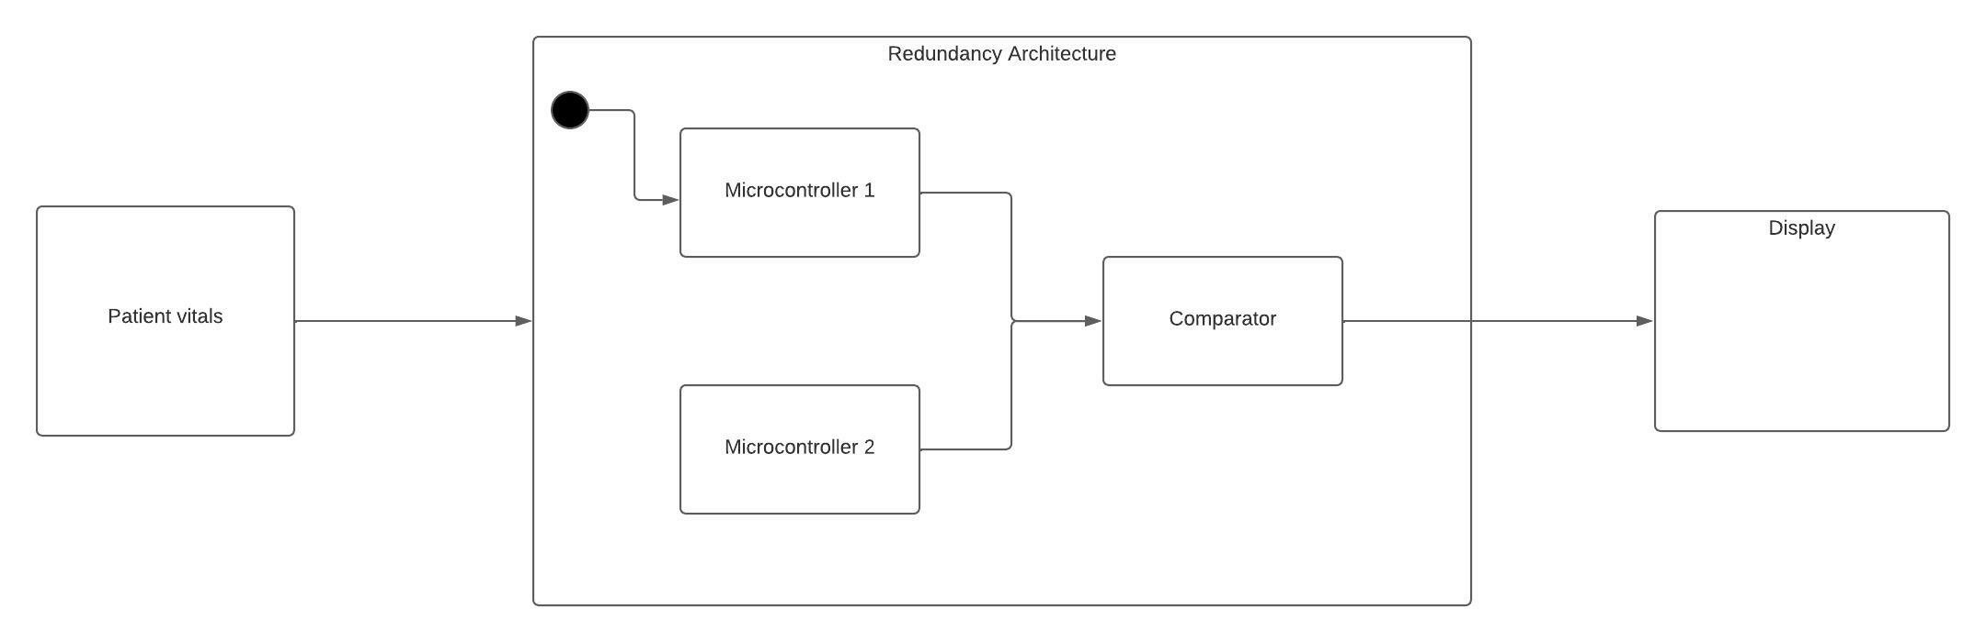
Fig 17: Block diagram redundancy

To protect against failure, the system will employ hardware redundancy. In our system, two microcontrollers will be used. Both are linked to a comparator to compare the results; if they both produce the same result, the system displays the vitals or sounds the alarm, depending on which condition the readings interpret. If the results are not the same, the system will be immediately stopped and display “error” because even the smallest of errors can give the doctor wrong information. To avoid common cause failure, the two microcontrollers will be of different types.

Sensors
We will use time redundancy for the sensors, and the results will be validated against previous results. The time between them will be milliseconds, and if they are equal, the result will be valid; if they are not, the system will stop because the information from the sensors must be accurate.

User interface

Proposed user interface

Default screen
Our user interface has a simple design, with the date and time displayed in the upper right corner. The main screen has various demarcations for parameters such as ecg, SP02, temperature, and blood pressure. Each parameter is represented by a bar on which the electronic charts are displayed. Buttons with various functions will also be included in our design; for example, the enter information button is used to enter patient information for later use; this can be done by the doctor or nurse who connects the patient to the monitoring system. When we press the display information button, we are taken to another interface that displays patient information. The print ECG button will print the electro diagram chart over a predetermined time period, whereas the stop alarm will stop be pressed to deactivate the alarm

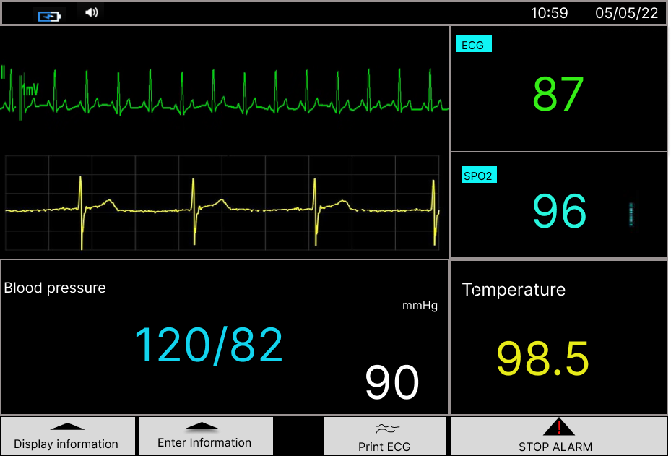

Fig 18. User interface default

Enter infromation
This button is pressed by the person connecting the patient to the system in order to quickly enter the patient's information in the intensive care unit. This is done by touchscreen capabilities. There is a save info button that is pressed after the information is entered. If the patient requires immediate attention, this procedure can be skipped. The system will always boot into the default configuration.

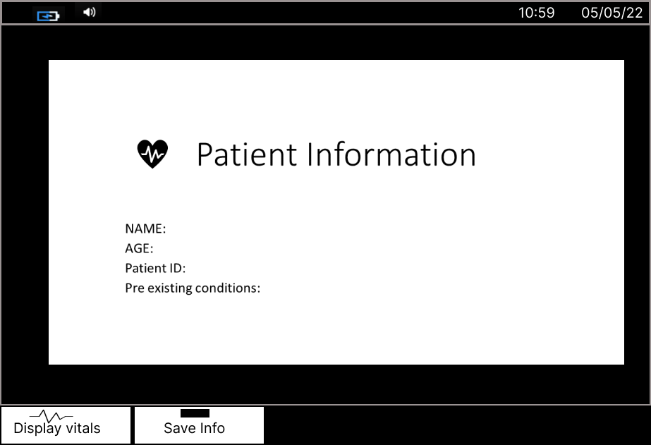

Fig 18: Enter Info interface

Display information

The display information interface is only activated when the display info button is pressed in this screen the doctor can see the information previously entered. The button display vitals is used to transition back to the default screen where the vitals are shown.

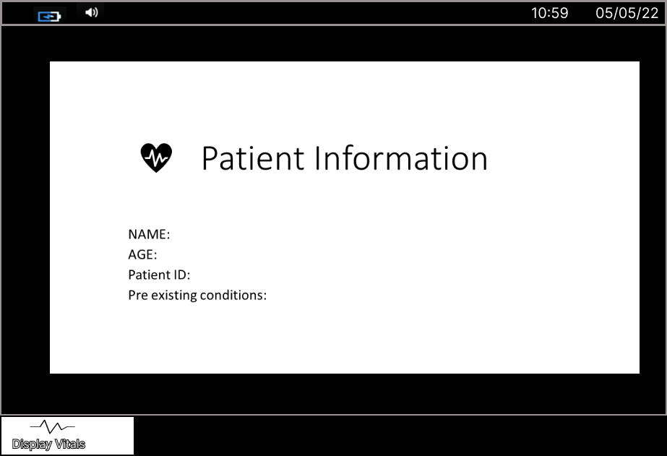

Fig 20: Display Info interface

USer interaction

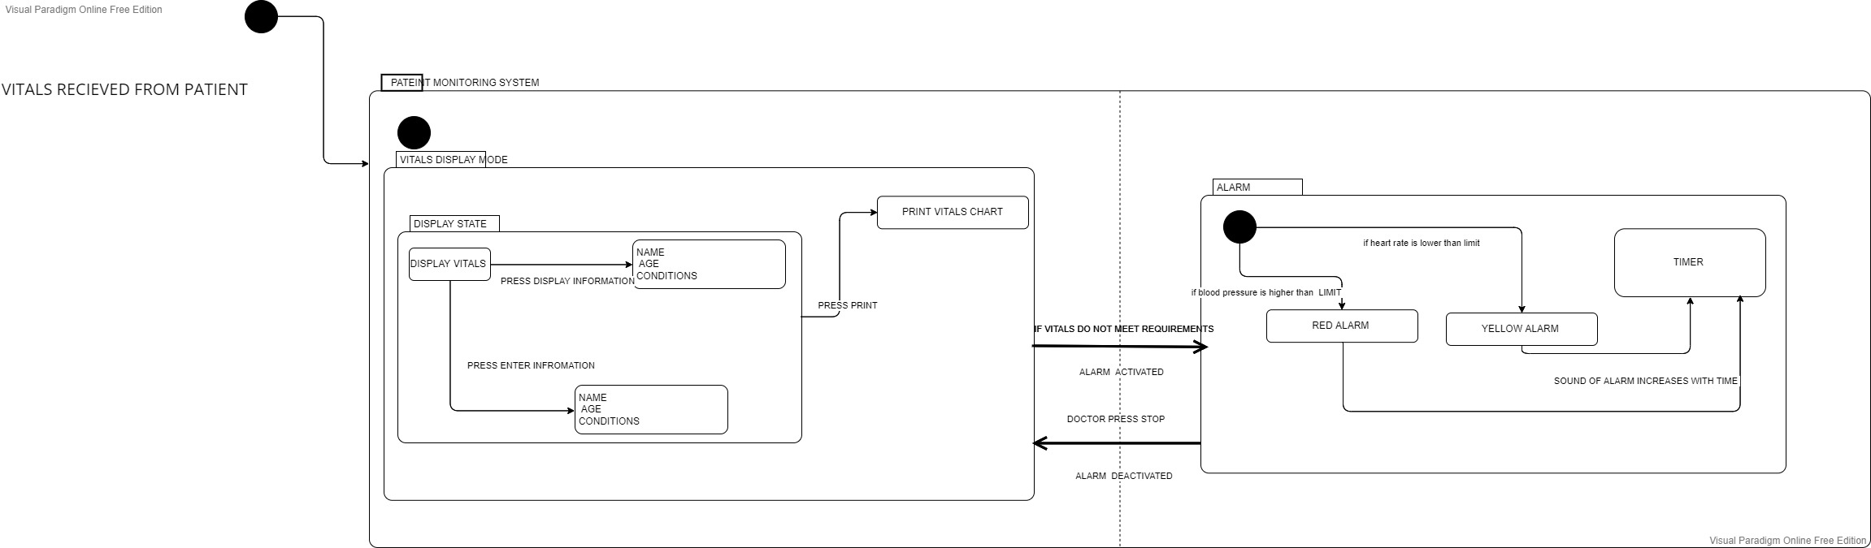

Fig 21: State chart of User interaction

Above is a state chart showing the behavior and state transitions of our intended system. The system receives vitals data from the patient through sensors and sends it to the microcontroller, which analyzes the data and sends the vitals data to be displayed on the screen. In the display state, the doctor or nurse can press the enter information or display information buttons to transition to whichever state is required. If the set conditions are not reached, the alarm is activated; the alarm might be red or yellow depending on the established conditions, and the sound level increases. A press of the stop alarm button transitions the system back into the default state where vitals are shown.

DISCUSSION
The overview of this paper is a well-defined patient monitoring system that is intended for use in a hospital's intensive care unit. The many components of this system are outlined in this work; from the system diagram in fig [1], we can see the three key aspects of the system, which are the sensor, processing, and display or alarm. Further ahead, models have been integrated to portray the behavioral and functional features of our system, such as a sequence diagram that depicts the series of activities that an actor interacting with the system will take. Redundancy is also used to prevent system mistakes, as its unique use case will result in a fatal outcome in the event of such errors.
In terms of the original problem that this system was created to answer, I feel we have come up with a well-defined and reliable solution. Our system will make this information readily available via the patient monitors, so the doctor will not have to manually check the patient vitals one by one. The device also notifies the doctor if the patient develops a critical state. As an added feature, we've inserted a red and yellow light to warn the doctor to the patient's critical state even before he has the chance to look at the vitals on the screen. I chose to add a patient information interface to my model after our interactive session in class, which can be accessible by pressing the display info button. Also, I included hardware redundancy design to ensure that in the event of a mistake, the system is alerted and shuts down, preventing the display of incorrect patient vitals, which could be critical.
I also made correction to my interface, I made it clearer to understand and simpler.

CONCLUSION

Overview

The goal was to create a gadget that not only monitors but also acts as an alarm system in the event of abnormal vital signs. The study presented demonstrates that a patient monitoring system can transmit and receive data in order to take timely action based on simulation results. This system uses various types of sensors put on a single system to provide an effective solution for upgrading an existing health system.
By using the system, the healthcare professionals can monitor, diagnose, and advice their patients all the time.
This system was created using a variety of engineering techniques. While the system does not need to be extremely sophisticated, it must meet stringent requirements because it is utilized in a healthcare context. For example, reliability must be satisfied to the maximum degree possible, as failure to do so could result in a doctor's misdiagnosis, which could result in death. The user interaction state chart in fig[21] depicts how humans should engage with the technology.
To achieve this, buttons and a touch screen interface were implemented, and the interaction design was kept simple to make it more useable. The hardware components were carefully chosen in order to achieve the highest level of reliability feasible, and the sensors were well characterized in order to provide a more in-depth understanding of their use.
Hardware redundancy is utilized to identify even the tiniest flaws in the system and shut it down instantly. The output of the sensors has also been given time redundancy.

Future directions
This system has great functional value to the doctors however some improvements can be made

Central ICU monitor
We can improve this system further by installing a central monitor in the doctor's office to which all patient monitors are routed. This central monitor will display the vitals that are also displayed on each monitor in the intensive care unit, allowing doctors to watch in real time from their offices. Alarms will be implemented in the central system to alert the doctor as to which patient has reached critical status.

Remote access version
A further improvement will be a remote access version of the system. With increase in demand for proper healthcare in urban as well as rural areas, this healthcare system with many features combined into one may increase efficiency and also help in reaching the far and needy. The patients and doctor will both be equal part of one system in this version. And the patient will monitor the results over an app on his phone ,the doctor would also be able to monitor the patients vitals and alert him if need be.

Acknowledgment
It is my pleasure to offer my heartfelt gratitude to Christopher Beck and Charles Steinmetz, our two professors in charge of the interactive session in this course. I appreciate their feedback and constructive criticism, as well as their advice and support. I'd also like to thank my classmates, whose projects inspired me to create my own system. Finally, Professor Ali Hayek for his redundancy lecture, which provided me with ideas for securing my system against failure.

References

- Ms Aishwarya D. Gavali et al. Int. Journal of Engineering Research and Application www.ijera.com ISSN : 2248-9622, Vol. 6, Issue 12, ( Part -2) December 2016, pp.26-29J. Clerk Maxwell, A Treatise on Electricity and Magnetism, 3rd ed., vol. 2. Oxford: Clarendon, 1892, pp.68–73.

